A Lightweight DNN-based IDS for Detecting IoT Cyberattacks in Edge Computing
Trong – Minh Hoang¹, Tuan - Anh Pham¹, Van - Viet Do², Van - Nhan Nguyen¹, Manh – Hung Nguyen²
¹ Telecommunication Faculty No1, Posts and Telecommunications Institute of Technology, Viet Nam
² Mathematics and Informatics Faculty, Thang long University, Ha Noi, Viet Nam
hoangtrongminh@ptit.edu.vn, anhpt.b17vt021@stu.ptit.edu.vn, vietdv.B18vt437@stu.ptit.edu, nhannv.B18vt314@stu.ptit.edu.vn, hung.nm@thanglong.edu.vn

Abstract— With the continuous growth of the Internet of Things applications, increasingly sophisticated and malicious network security attacks have been posing new security requirements. One of the first protection solutions to ensure security is to use an intrusion detection system (IDS) for detecting cyberattacks. Another hand, edge computing technology has been bringing many benefits to communication network infrastructure and IoT applications in terms of performance and privacy. However, the implementation of IDS systems on edge devices encounters many obstacles stemming from resource constraints of edge devices. Hence, machine learning-based IDS systems have emerged to address such challenges. In this paper, we propose a lightweight deep neuron network-based IDS suitable for deployment at edge devices while still ensuring high attack detection accuracy. The evaluation results on the IoT23 dataset with various cases show that our proposed model has overcome previous proposals and reached attack detection ability as 99%.
Keywords—Edge computing, intrusion detection system, deep neuron network, IoT 23 dataset.

Introduction
Recent years have seen the massive growth of the Internet of Things (IoT) and its impact on various sectors of social aspects, including agriculture, healthcare, transportation, and industry [1]. IoT systems have connected billions of objects and gathered big data for intelligent computations and automation to connect all physical and virtual things to the digital environment. The Internet of Things is generally accepted as a critical component of the digital revolution reshaping our civilization. The rapid growth of IoT applications according to user needs brings not only new benefits but also creates new challenges related to network performance and security [2].
As the Internet of Things approach human activities, the necessity for security capabilities increases. Conversely, cyberattacks on IoT are becoming more sophisticated, and the effects are devastating [3]. To face the changing issues posed by the Internet of Things, creative approaches have been developed in both the research and practice domains. IDS is regarded as the first technological barrier of network security systems to detect intrusions. Signature-based, anomaly-based, and hybrid-based are regarded main classifications of an intrusion detection system for network analysis. Machine learning approaches significantly contribute to identifying different kinds of network intrusions. IDS employs machine learning to increase accuracy and reduce attack detection time in combating sophisticated attacks [4]. These solutions utilize historical data to examine current data for anomalies [5]. Another critical aspect in the life-cycle of advanced IDS is the evaluation of their detection capabilities. Many popular datasets are available for IDS evaluation, such as BoT-IoT, IoT Network Intrusion, MQTT-IoT-IDS2020, IoT-23, and IoT-DS-1 datasets [6].
The introduction of edge computing technology has provided numerous benefits regarding load sharing, reliability, scalability, and a coherent integration between the Internet of Things and modern network infrastructure [7]. However, such a decentralized architecture introduces new deployment requirements for IDSs at the network's edge. This problem is a new challenge since machine learning-based solutions usually require large data sets to ensure accuracy. To tackle this issue, we propose a lightweight DNN-based IDS model that simultaneously fulfills two criteria: a minimum amount of training data that meets resource constraints at the network's edge and accuracy assurance. The following are the primary contributions of this study:
- Propose a novel lightweight IDS based on DNN consisting of just two layers.
- Test and evaluate the proposed model with other proposals to prove its performance.
The structure of this paper is as follows: The following section provides a summary of the work directly related to our study. The third section detail our proposed methodology and model. In section IV, the simulation and evaluation results are listed. In the last section, the research's conclusion and directions for future research.

Related Work
Existing IDSs are recognized to have numerous issues, including a high percentage of false-positive alerts, a lengthy detection time, and practical adaptation ability. IDS systems based on machine learning can detect existing, new, and lightweight attacks without extensive training or human activity. They are techniques for identifying data patterns and predicting future trends [8].
The authors in [9] developed a CNN-based IDS model that achieves 97% accuracy on the KDD'Cup99 data set and outperforms conventional machine learning techniques (such as KNN, SVM). In [10], a lightweight ML-based IDS model, IMPACT, is proposed. Working on the AWID dataset, the authors reduce the number of features through feature extraction and selection using a stacked autoencoder (SAE), mutual information (MI), and C4.8 wrapper. To adapt recent IoT datasets, the authors in [11] designed and developed a novel anomaly-based intrusion detection model for the Internet of Things (IoT) networks. A multiclass classification model is initially created using a convolutional neural network model. The proposed model uses 1D, 2D, and 3D convolutional neural networks. The proposed convolutional neural network model is evaluated using the BoT-IoT, IoT Network Intrusion, MQTT-IoT-IDS2020, and IoT-23 datasets for intrusion detection.
The lightweight aspect of the DNN-based IDS approach for edge devices has attracted attention in recent years. The authors of [12] proved the feasibility of deploying IDS to the IoT edge network. To identify network attacks, the authors aimed to install two machine learning models, Isolation Forest (iForest) and Local Outlier Factor (LOF), on devices with limited resources. Experiments indicate that the model can classify four types of attacks while utilizing low computational resources. The authors in [13] developed an anomaly-based detection system that uses DNN to analyze and learn the behavior of the DDoS attack and thus detect an attack by its behavior. The proposed model has been evaluated on the UNSW-NB15 dataset to reacher accuracy of 94% for DDoS Botnet attacks. However, this proposal uses the original database set and no preprocessing algorithms to assist in reducing the system complexity. Working with the CIC-IDS2017 dataset, the authors in [14] introduce a DNN-based IDS named Realguard, which could detect ten attacks with accuracy up to 99.57%. To handle zero-day attacks, the authors of [15] propose and enhance IDS detection mechanisms via two processes: using a deep neural network (DNN) model with novel features for this attack and merging the DNN model and principal component analysis (PCA) to increase security and performance on the CSE-CICIDS2018 dataset. The proposed detection mechanism combines DNN, PCA, statistical, and knowledge-based techniques to provide more efficiency than existing IDS resulting in a 98% accuracy rate.
Through the studies mentioned above, we recognize that to deploy ML-based IDSs, dimensionality reduction studies on various data sets and ML algorithms have been conducted. They provided various data processing methods and training models. In addition, these data indicate that the testing of various kinds of attacks revealed varying degrees of precision. To identify recent attacks, we present a lightweight DNN-based IDS model that can be installed on edge computing devices such as IoT gateways in this study. The accuracy and other performance metrics of our proposed model are better than those proposed by previous studies, as demonstrated by testing on the IoT23 database with several distinct scenarios. Our proposed model brings the attack rate with an accuracy of 99.23%.

The proposed model

The overview of the IDS based on IoT edge computing
Resource-constrained IoT devices, such as sensors, actuators, and IoT gateways, have gained popularity.
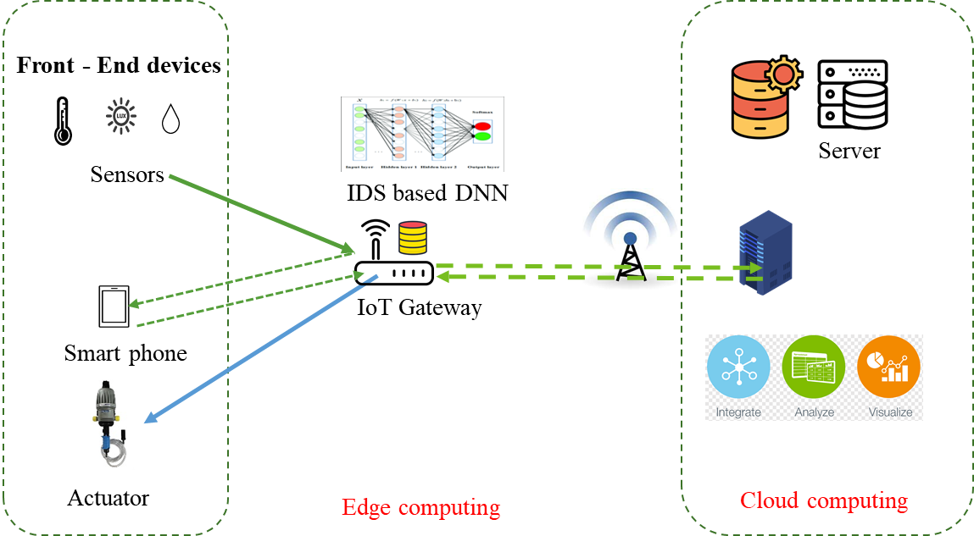
Fig. 1. A typical IDS at edge computing structure
IoT applications create vast amounts of data in real-time, which is a desirable objective for AI systems [16]. A typical IDS deployed in edge devices is shown in Fig 1. To deal with intelligent attacks from a large number of IoT devices, machine learning algorithms such as DNN have been integrated into the IDS. This approach reduces the computational load at the processing center as well as improves the performance of the wireless links and, at the same time, improves the privacy of the users.

The little IoT23 dataset
We use the publicly available little IoT23 dataset [17]. The dataset includes 20 malware captures executed in IoT devices and 3 captures for benign IoT device traffic. It was first published in January 2020, with snapshots from 2018 to 2019. This IoT network traffic was recorded in Stratosphere Laboratory, the AIC team, FEL, CTU University, and the Czech Republic. In which extracted features are exported to a CSV-formatted file.
The IoT-23 dataset classifies attacks into 16 categories: Part-Of-A-Horizontal-PortScan, Okiru, Okiru-Attack, DDoS, C&C-Heart Beat, C&C, Attack, C&C-, C&C- Heart Beat Attack, C&C-File download, C&C-Tori, C&C-Heart Beat File Download, C&C-Mirai. The data file has fifteen malicious layers and one secure layer. The preprocessed data is divided into three sets for categorization: training, validation, and testing. Using the 80/20 rule, the dataset was divided with 80% for training and 20% for testing. The segmented technique guarantees equal samples for training, validation, and testing from each processing layer.

The proposed model and training process
The feature selection strategy minimizes overfitting, speeds up model training, and allows the model to be less prone to test errors. We used a feature selection technique called PCA (Principal Component Analysis) in our prosed model in Figure 2. Figure 2 depicts the main components of our proposed model.
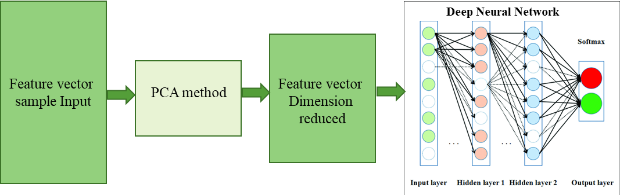
Fig. 2. Main components of the proposed model
With the original input data equivalent to a sample input, including all the original features of the dataset, the feature vector is entered into the model block to analyze the principle components as the PCA method. The analysis aims to analyze and evaluate vast amounts of information in huge data sets.
After determining the amount of important information, we will test the accuracy and efficiency of each amount of information by feeding the reduced dimensional feature vector into a fully connected neural network with 64 nodes that are then compressed down to 32 nodes to learn weights with a 'gelu' activation function and a dropout layer containing five percent of the excess neurons in a layer of neurons. In the cross classifier problem, the model's output is a softmax function with 16 output nodes corresponding to 16 types of attacks. We implement and simulate the 'Adam optimizer' optimization function and use the cross-entropy function to adjust the optimization weights. The learning rate is significant in deep learning algorithms since it specifies the number of steps a model takes during each iteration. In the study, 0.00001 was identified as the optimal learning rate with the highest detection rate. As the system trains, the loss function becomes inversely proportional to its output, and the error tendency decreases as the network's accuracy improve.
To minimize overlearning, we developed an early stop training method. Training is terminated when the validation error function does not decrease after a predetermined number of rounds—adjusting the number of epochs to provide the best possible network accuracy during the test period to the point where network accuracy relative to the epoch no longer grows.

Data preprocessing
The first stage involves processing raw network traffic. This process extracts the network feature from the conn.log.labeled file in the dataset. The IoT-23 dataset classifies attacks into 16 categories: Part-Of-A-Horizontal-PortScan, Okiru, Okiru-Attack, DDoS, C&C-Heart Beat, C&C, Attack, C&C-, C&C- Heart Beat Attack, C&C-File download, C&C-Tori, C&C-Heart Beat File Download, C&C-Mirai. The data file has fifteen malicious layers and one safe layer. For categorization purposes, the preprocessed data is divided into three sets: training, validation, and testing. Using the 80/20 rule, the dataset was divided with 80% for training and 20% for testing. The segmented technique guarantees an equal amount of samples for training, validation, and testing from each processing layer.
- Attack Types of The IoT 23
No | Types | 100k | 500k | 1000k | original
0 | Attack | 9398 | 9398 | 9398 | 9398
1 | Benign | 100000 | 500000 | 1000000 | 30854315
2 | C&C | 21995 | 21995 | 21995 | 21995
3 | C&C FileDownload | 53 | 53 | 53 | 53
4 | C&C HeartBeat | 33673 | 33673 | 33673 | 33673
5 | C&C HeartBeat Attack | 834 | 834 | 834 | 834
6 | C&C HeartBeat FileDownload | 11 | 11 | 11 | 11
7 | C&C Mirai | 2 | 2 | 2 | 2
8 | C&C PartOfAHorizontalPortScan | 888 | 888 | 888 | 888
9 | C&C Torii | 30 | 30 | 30 | 30
10 | DDoS | 100000 | 500000 | 1000000 | 19538713
11 | FileDownload | 18 | 18 | 18 | 18
12 | Okiru | 100000 | 500000 | 1000000 | 60990708
13 | Okiru Attack | 3 | 3 | 3 | 3
14 | PartOfAHorizontalPortScan | 100000 | 500000 | 1000000 | 213852924
15 | PartOfAHorizontalPortScan Attack | 5 | 5 | 5 | 5
Sum | 16 | 466910 | 2066910 | 4066910 | 325303570
This study aims to have the most optimal model possible while ensuring accuracy in deploying the IDS model on edge computing devices. Hence, we examine the subset of the little IoT 23 database over a small amount as 1 million samples/ attack type, 0.5 million samples/ attack type, and 1 million samples/ attack type. The subset databases as shown in the table below. In the experimental test, we validate the first case as 1 million samples/ attack type.

Features processing
Our data preprocessing steps are better than those described in [11]. Instances of data sets are labeled as safe or malicious as follows: (1) Stream IDs, source IP addresses, destination IP addresses, and timestamps have been removed from all data sets. (2) The database format's catalog type features must include a data field denoting and encoding. In [11], the authors set all data sets with a value of 0 for NaN values. To eliminate large values and accelerate the calculation, the author has normalized the input feature columns within a predetermined range (-1,1). The feature columns of the entire dataset are encoded using one-hot coding, with each type in each column represented by a binary string. Normal, Attack, Mirai, File download, Heart Beat, C&C, Torii, Port Scan, DDoS, and Okiru attack types are labeled 0 to 9 in the IoT-23 dataset. However, the maximum number of dimensions for the data is 64. Moreover, features including (ID Flow), (source IP), (destination IP), timestamp, 'label,' 'local resp,' and 'local orig' have been removed. We utilize multiclass classification and remove 'label,' 'local resp,' and 'local orig' since they contain binary or NaN values.
The data file has two columns of IPv4 address type, 'id.orig h' and 'id.resp h', each containing the value of a different IP address. The 'ipaddress' library is used to transform IPv4 address data to digital format as a standard for IP address encoding. This library will convert IP addresses to the digital format by converting each octet to an 8-bit binary and then concatenating 4 octets to produce a 32-bit binary string. And from 32-bit binary, we'll convert back to decimal numbers.
The missing data processing is processed by using the mean value of each attack type related to that feature. This means missing values in a feature column to be replaced with the average value corresponding to 16 attack types. By extension, attack types of the same kind have values close to the feature's average value.

Exprimental Resuts and Discussion
To evaluate the effectiveness of our proposed model, we use IoT 23 public database to test. First, we use the original IoT 23 dataset and the reduced set of Lite IoT23 similar to those in [11].

Evaluation results on the original IoT dataset
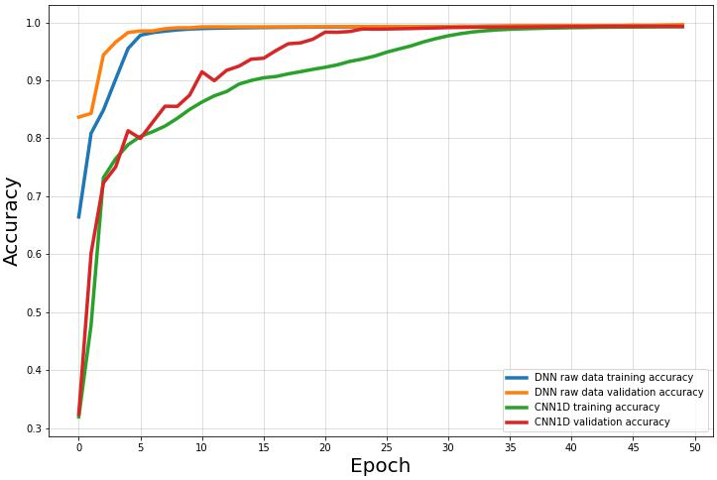
Fig. 3. Accuracy validation on original IoT dataset
We compare the training process between the Convolutional Neuron Network model and our proposed Deep Neuron Network model without dimensionality reduction, and the obtained results are shown in figure 3 and figure 4. The fact that the function representing accuracy is dependent on the epoch number demonstrates that our proposed model has a faster convergence rate and more accuracy than the CNN training model.
We describe the loss function in Figure 4. It is used to quantify how good or bad the model is working. The results show that our proposed model gives outstanding results.
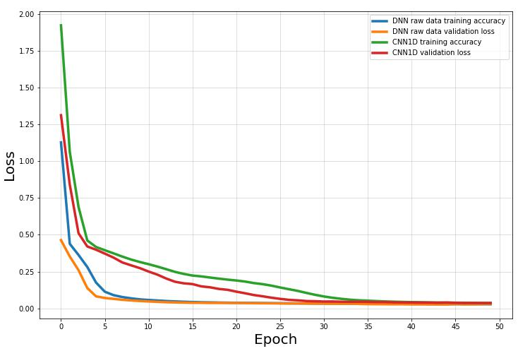
Fig. 4. Loss validation on original IoT dataset

Evaluation results on the little IoT dataset
This work tests the little IoT 23 dataset with dimensional reduction. The results compared with [11] in the evaluation of accuracy and loss function are shown in Figures 5 and 6, respectively.
Fig. 5. Accuracy validation on the little IoT dataset
Fig. 6. Loss validation on original IoT dataset
Our proposed model is superior at early convergence around the 6th or 7th epoch, achieving excellent training precision. In contrast, the CNN model looks to have difficulty updating the weight and Loss function value with accuracy from the first to the 21 epoch, as evidenced by the instability of the training results.
Training time. In the actual test, our training takes approximately 600-700 seconds per epoch, and the total training time with CNN ranges from 8.33 to 9,722 hours. With the proposed DNN model, the training process takes approximately 20-24 (seconds) per epoch, and the entire procedure takes approximately 18.3 - 20 (minutes).
The number of parameters. In the same framework, the number of parameters is a determining factor in the model's effectiveness. For the CNN model, 265,040 parameters are required. While DNN only needs 4,784 parameters. The experimental settings used to compare the CNN and DNN models are listed in the table II below.
- A comarison of the practical performance tests
Model | Accuracy | Training time | parameters
Proposed DNN | 99.23% | ~ 20 mins | 4.784
CNN | 99.36% | ~ 9 hours | 365.040

Evaluation results on the subset of the little IoT dataset
To implement the complete lightweight DNN model into an IoT gateway device, we replicate the process of gathering tiny amounts of device data and calculating gradients in small batches of dispersed data. We used the TensorFlow library and Keras implementation. All our tests and simulations were performed on the CPU Xeon X5675, 3.07Ghz with an Nvidia Quadro K4000 GPU with 4 GB of RAM. Therefore, we split the amount of data of the IoT23 Lite set (8.8GB) to train with the 1 million samples/ attack.
With this scenario, the number of dimensions is reduced from 33 dimensions from the original data to 2 dimensions, the amount of information is only about: (r_K a) in PCA = 9% to rK_b = 5.1%, and learned and trained to achieve ~87% accuracy. In other cases, the data be extensive and costly to train. The results and performance for each dimensionality reduction case are as follows: rK = the amount of information remaining after dimensionality reduction. The relationship between several features and reduction rate and accuracy are shown in table III.
- Feature reduction
N features | 2 | 3 | 4 | 5 | 6 | 7 | 8 | 9 | 10
rK a | 0.09 | 0.15 | 0.21 | 0.269 | 0.326 | 0.38 | 0.43 | 0.48 | 0.52
rK b | 0.15 | 0.21 | 0.27 | 0.325 | 0.38 | 0.43 | 0.48 | 0.52 | 0.55
Accuracy | 0.87 | 0.87 | 0.99 | 0.992 | 0.993 | 0.99 | 0.99 | 0.99 | 0.99
The training process and accuracy are presented below, including the model learned under each specific scenario and data type. With 30% of the dataset, we have 5-dimensional data left, ~99% accuracy.
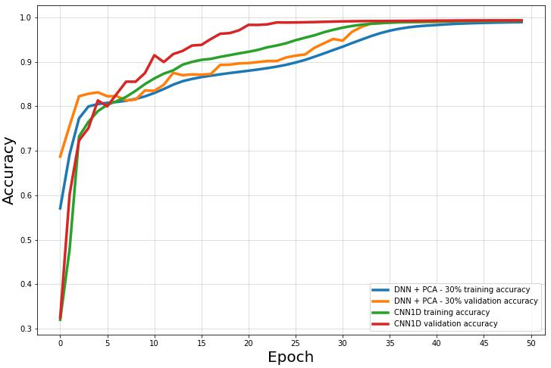
Fig. 7. Accuracy validation on the subset of the little IoT dataset
As shown in figures 7 and 8, we do experiment with the PCA dimensionality reduction method on the IoT23 lite dataset, and the test results are surprising when we reduce the amount of information in the dataset to only 30% of the information corresponding to 5 dimensions/ 33 original dimension, reaching 99.23% accuracy of lightweight DNN model compared to CNN of 99.36%.
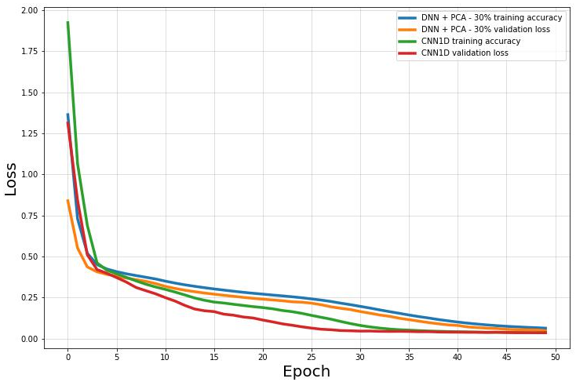
Fig. 8. Accuracy validation on the subset of the little IoT dataset

The overall performance of the proposed model
We perform the evaluations on the reduced dataset to fit edge computing devices and compare it with the IDS model using CNN, as shown below. The proposed model is validated using the accuracy, precision, recall, and F1 score in table IV.
- Full Performance Parameters
Model | CNN |  |  | DNN + PCA 30% |  |  | Samples
Class | Precision | Recall | F1 Score | Precision | Recall | F1 Score | Samples
0 | 0.99 | 1.00 | 0.99 | 0.98 | 1.00 | 0.99 | 200241
1 | 0.86 | 0.99 | 0.92 | 0.83 | 0.97 | 0.89 | 1871
2 | 0.97 | 0.80 | 0.88 | 0.96 | 0.79 | 0.87 | 4343
3 | 1.00 | 0.55 | 0.71 | 1.00 | 0.36 | 0.53 | 11
4 | 0.98 | 0.74 | 0.84 | 0.98 | 0.64 | 0.77 | 6684
5 | 0.00 | 0.00 | 0.00 | 0.00 | 0.00 | 0.00 | 177
6 | 0.00 | 0.00 | 0.00 | 0.00 | 0.00 | 0.00 | 3
7 | 0.00 | 0.00 | 0.00 | 0.50 | 0.50 | 0.50 | 2
8 | 0.00 | 0.00 | 0.00 | 0.00 | 0.00 | 0.00 | 155
9 | 1.00 | 0.43 | 0.60 | 0.75 | 0.43 | 0.55 | 7
10 | 1.00 | 1.00 | 1.00 | 1.00 | 1.00 | 1.00 | 199168
11 | 0.17 | 1.00 | 0.29 | 0.00 | 0.00 | 0.00 | 2
12 | 1.00 | 1.00 | 1.00 | 1.00 | 1.00 | 1.00 | 200503
13 | 0.00 | 0.00 | 0.00 | 0.00 | 0.00 | 0.00 | 1
14 | 0.99 | 0.99 | 0.99 | 0.99 | 0.99 | 0.99 | 200216
15 | 0.00 | 0.00 | 0.00 | 0.00 | 0.00 | 0.00 | 5

Conclusion
Due to its effectiveness, the challenge of implementing ML-based IDS systems for IoT application contexts at the edge of computing is an attractive research direction for both researchers and implementers. Lightweight models result from resource constraints of edge devices that impose requirements to reduce data size while maintaining high accuracy. In this research, we propose a lightweight DNN-based intrusion detection system model suitable for deployment on IoT gateway devices. The evaluation results demonstrate that our proposal is better than previous research. Based on these findings, we will proceed to integrate IoT on actual devices in a practical environment.

Acknowledgment
The The study was funded by under the statement of work number POS-459341/Project 3 of the Research Agreement Number POS-458996 between Qualcomm Technologies, Inc and Posts and Telecommunications Institute of Technology.

References
- Khanna, Abhishek, and Sanmeet Kaur. "Internet of things (IoT), applications and challenges: a comprehensive review." Wireless Personal Communications 114.2 (2020): 1687-1762.
- Yao, Xuanxia, et al. "Security and privacy issues of physical objects in the IoT: Challenges and opportunities." Digital Communications and Networks 7.3 (2021): 373-384.
- Tahsien, Syeda & Karimipour, Hadis & Spachos, P.. (2020). Machine learning-based solutions for security of Internet of Things (IoT): A survey. Journal of Network and Computer Applications. 161. 102630. 10.1016/j.jnca.2020.102630.
- Hassan, Wan Haslina. "Current research on Internet of Things (IoT) security: A survey." Computer networks 148 (2019): 283-294.
- Bhatt, Shobha, and Prakash Rao Ragiri. "Security trends in Internet of Things: A survey." SN Applied Sciences 3.1 (2021): 1-14.
- Ali, Rao Faizan, Amgad Muneer, P. D. D. Dominic, Shakirah Mohd Taib, and Ebrahim AA Ghaleb. "Internet of Things (IoT) Security Challenges and Solutions: A Systematic Literature Review." In International Conference on Advances in Cyber Security, pp. 128-154. Springer, Singapore, 2021.
- Carvalho, Gonçalo, Bruno Cabral, Vasco Pereira, and Jorge Bernardino. "Edge computing: current trends, research challenges and future directions." Computing 103, no. 5 (2021): 993-1023.
- Suthishni, D. Nethra Pingala, and KS Senthil Kumar. "A Review on Machine Learning based Security Approaches in Intrusion Detection System." 2022 9th International Conference on Computing for Sustainable Global Development (INDIACom). IEEE, 2022.
- Liu, Y.; Liu, S.; Zhao, X. Intrusion detection algorithm based on convolutional neural network. In DEStech Transactions on Engineering and Technology Research; DEStech: Lancaster, PA, USA, 2017.
- Lee, Seo Jin, Paul Yoo, A. Taufiq Asyhari, Yoon-chan Jhi, Lounis Chermak, Chan Yeob Yeun and Kamal Taha. "IMPACT: Impersonation Attack Detection via Edge Computing Using Deep Autoencoder and Feature Abstraction." IEEE Access 8 (2020): 65520-65529.
- Ullah, Imtiaz, and Qusay H. Mahmoud. "Design and development of a deep learning-based model for anomaly detection in IoT networks." IEEE Access 9 (2021): 103906-103926.
- Eskandari, M.; Janjua, Z.H.; Vecchio, M.; Antonelli, F. Passban IDS: An intelligent anomaly-based intrusion detection system for IoT edge devices. IEEE Internet Things J. 2020, 7, 6882–6897.
- Shareena, Jishma, Aiswarya Ramdas, and Haripriya AP. "Intrusion detection system for iot botnet attacks using deep learning." SN Computer Science 2, no. 3 (2021): 1-8.
- Nguyen, Xuan-Ha, Xuan-Duong Nguyen, Hoang-Hai Huynh, and Kim-Hung Le. "Realguard: A lightweight network intrusion detection system for IoT gateways." Sensors 22, no. 2 (2022): 432.
- Al-Fawa'reh, Mohammad, et al. "Cyber threat intelligence using PCA-DNN model to detect abnormal network behavior." Egyptian Informatics Journal (2021).
- Z. Chang, S. Liu, X. Xiong, Z. Cai, and G. Tu, "A Survey of Recent Advances in Edge-Computing-Powered Artificial Intelligence of Things," in IEEE Internet of Things Journal, vol. 8, no. 18, pp. 13849-13875, 15 Sept.15, 2021.
- Sebastian Garcia, Agustin Parmisano, & Maria Jose Erquiaga. "IoT-23: A labeled dataset with malicious and benign IoT network traffic" (Version 1.0.0) [Data set]. Zenodo, 2020.

